CS 161A: Programming and Problem Solving I

# Midterm Exam Version A

| **Academic Integrity** **You may NOT, under any circumstances, begin a programming assignment by looking for completed code on StackOverflow or Chegg or any such website, which you can claim as your own. Please check out the** [**Student Code of Conduct at PCC.**](https://www.pcc.edu/student-conduct/conduct/quick-view-of-policy/)  The only way to learn to code is to do it yourself. The assignments will be built from examples during the lectures, so ask for clarification during class if something seems confusing. If you start with code from another source and just change the variable names or other content to make it look original, you will receive a zero on the assignment.  I may ask you to explain your assignment verbally. If you cannot satisfactorily explain what your code does, and answer questions about why you wrote it in a particular way, then you should also expect a zero. |
| --- |

## 

It’s that time again - the Rock Collecting Championships are here! Who will win the top three prizes?

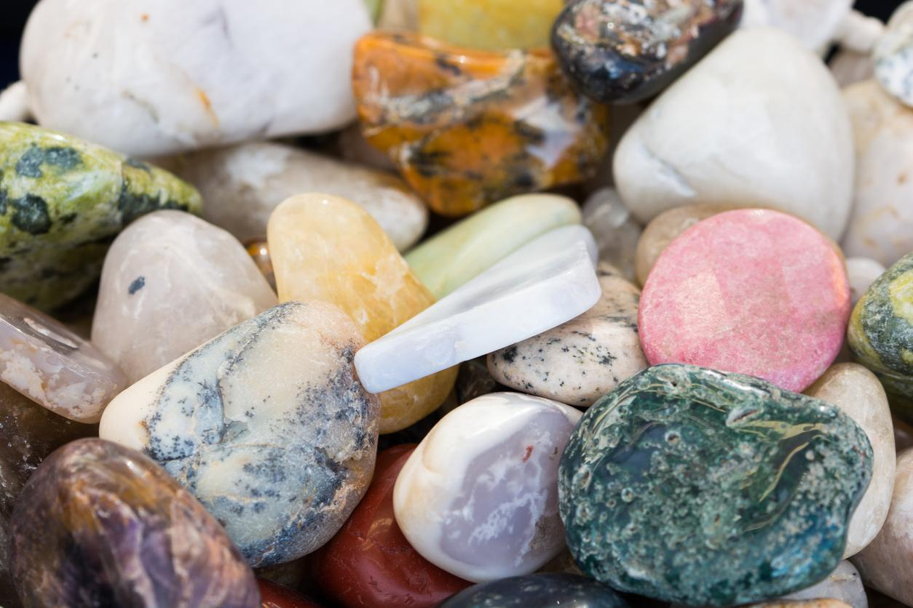

## Purpose

The purpose of this midterm exam is to test your knowledge of the concepts learned in this course so far:

* Variables and data types
* Expressions
* Input and output
* Reading in strings with spaces
* Data type casting
* Conditionals

## Task

* Open the [Algorithmic Design Document](https://docs.google.com/document/d/1Y0kHPoUWHcbH-_0yma7sMCUR0EvLL7CKEvTGTetqEmU/edit?usp=sharing), make a copy, and follow the steps to create your algorithm.
* You must express your algorithm as **pseudocode** or a **flowchart.**
* Please take a look at the **sample run** below before you continue!
* Write a program to output the winners of a Rock Collecting Competition.
* Prompt the user for three contestants: input their names as strings and the number of rocks collected as integers.
* Contestant names may contain spaces, use getline() to read in the string.
* Include the contestant name in the prompt for the number of rocks.
* If the number of rocks entered is less than 0, print a warning and set the number of rocks to 0.
* After the three contestants have been entered, determine the first, second and third place winners and print a message. Your logic must account for three way and two way ties (see sample run). Use appropriate conditional statements to write this code - this is the coding construct you are being tested on.
* Calculate and print the average number of rocks collected - the average should print two decimal places. You must **define and use an integer constant NUM_PLAYERS = 3** for this calculation.
* Print a welcome and goodbye message.
* Use only the concepts we have learned so far.

## Criteria for Success

* Test your program using the following sample runs, making sure you get the same output when using the given inputs (in **blue**).
* Try other inputs to test different combinations of winners (1 and 2 tie for first, 2 and 3 tie for first, 1 and 3 tie for first, etc.).

| Welcome to the Rock Collector Championships!  Enter player 1 name: **Gordan Freeman**  How many rocks did Gordan Freeman collect? **-9**  Invalid amount. 0 will be entered.  Enter player 2 name: **Link**  How many rocks did Link collect? **45**  Enter player 3 name: **D. Va**  How many rocks did D. Va collect? **45**  Link and D. Va are tied for first place.  Gordan Freeman is in second place!  The average number of rocks collected by the top three players is 30.00 rocks!  Congratulations Rock Collectors! |
| --- |
| Welcome to the Rock Collector Championships!  Enter player 1 name: **Mario**  How many rocks did Mario collect? **56**  Enter player 2 name: **Master Chief**  How many rocks did Master Chief collect? **56**  Enter player 3 name: **Sonic**  How many rocks did Sonic collect? **56**  It is a three way tie!  The average number of rocks collected by the top three players is 56.00 rocks!  Congratulations Rock Collectors! |
| Welcome to the Rock Collector Championships!  Enter player 1 name: **King Dedede**  How many rocks did King Dedede collect? **57**  Enter player 2 name: **Samus**  How many rocks did Samus collect? **102**  Enter player 3 name: **Kirby**  How many rocks did Kirby collect? **62**  Samus is in first place!  Kirby is in second place.  King Dedede is in third place.  The average number of rocks collected by the top three players is 73.67 rocks!  Congratulations Rock Collectors! |

* Complete all sections of your Algorithmic Design Document.
* Include **pseudocode** or a **flowchart** in part d of the design document.
* Please open and compare your work with the [grading rubric](https://docs.google.com/document/d/1OgJpTGzDOtA6GMqi87ggiLgu79zw71-I80jPjC4eZMQ/edit?usp=sharing) before submitting.
* Remember to follow all [style guidelines](https://docs.google.com/document/d/1avQh7119eRLYZg2ctgeJ57eNRr-KgLr56h2eBxi9_dQ/edit?usp=sharing).
* Download your Algorithmic Design Document as a PDF (File -> Download -> PDF), rename it to mid.pdf.
* Name your C++ source file mid.cpp and upload with mid.pdf to the D2L assignment.
* Do your own work. Consult the syllabus for more information about academic integrity.